# Help Document for Navigating the Software

## Login Screen

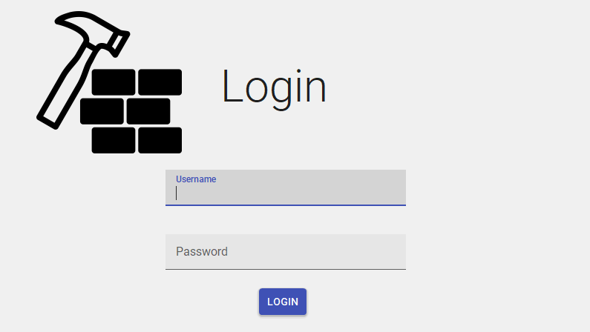A simple login screen displaying the logo, if the input credentials match a username and password the user is logged in

## Main Screen

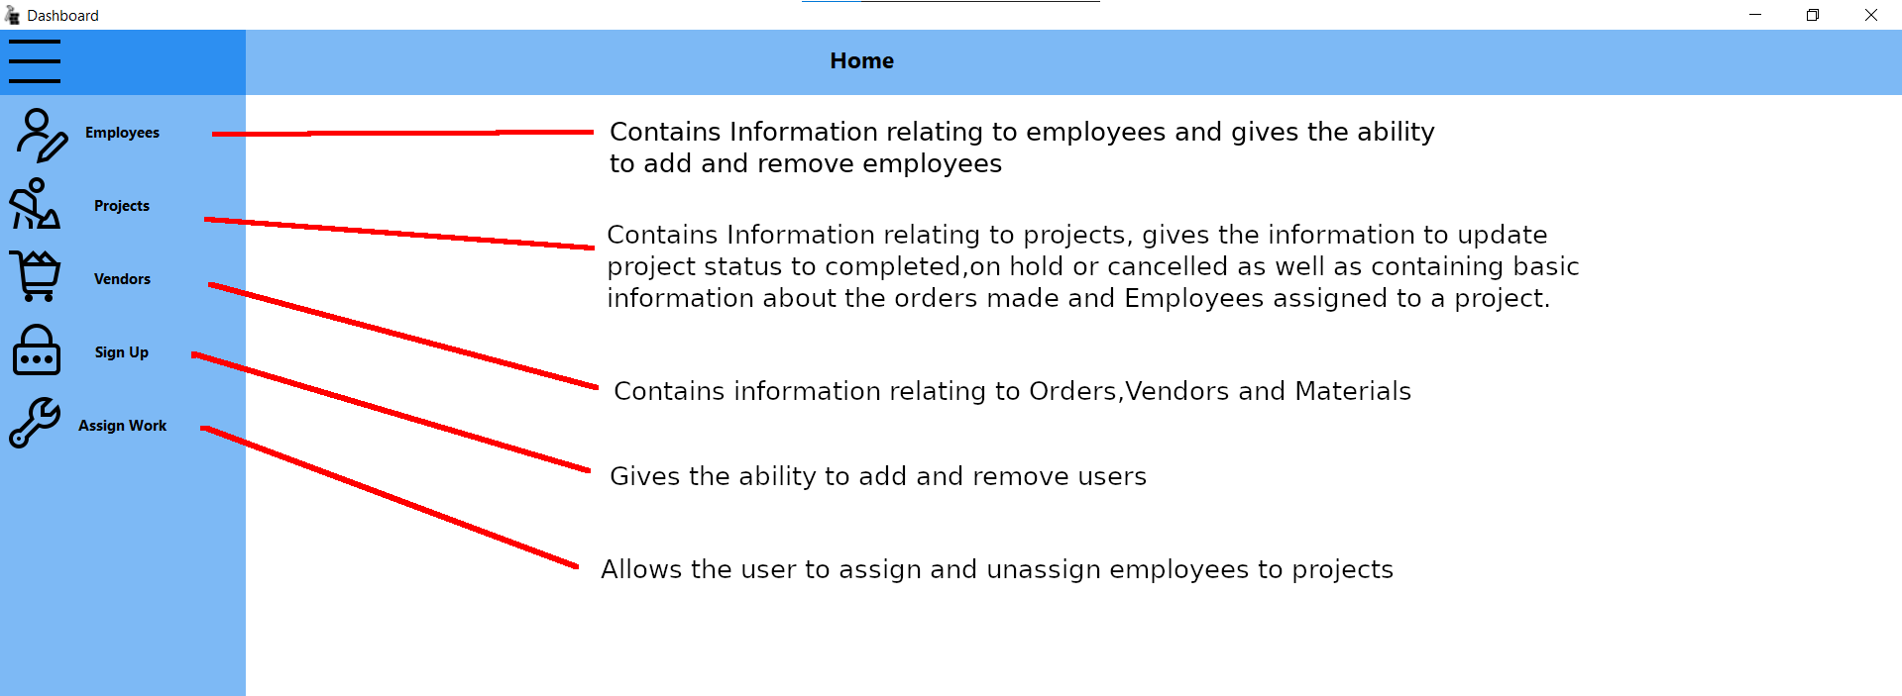

## Registration

Registration is used for entering new employee info and updating or removing employee information.

Updating or deletion can be performed after double clicking on an entry in the table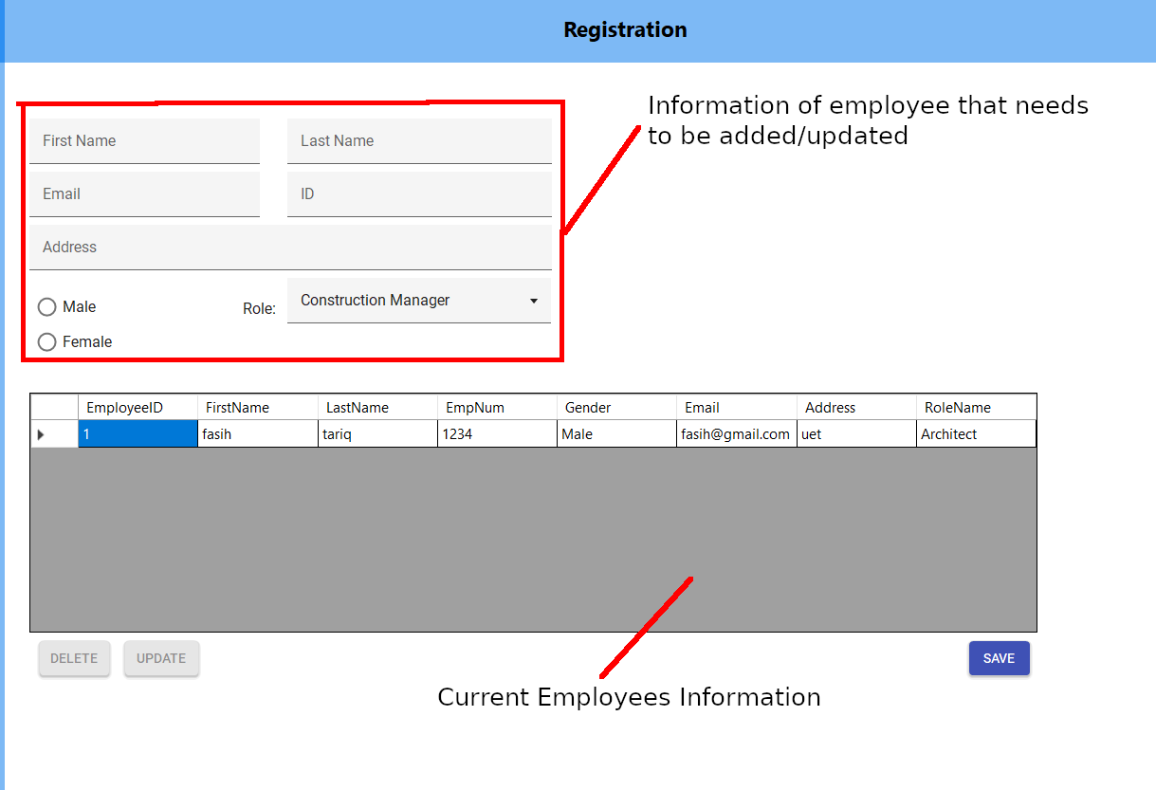

## Projects

Information can be changed or viewed relating to projects, some basic information about how many orders have been placed and how many employees have been assigned to this project can also be viewed by double clicking the project

## Vendors

Vendors contains a few sub menus relating to order placing, materials and vendors

## Vendors Submenu

Vendors tab is for adding removing and updating vendors.

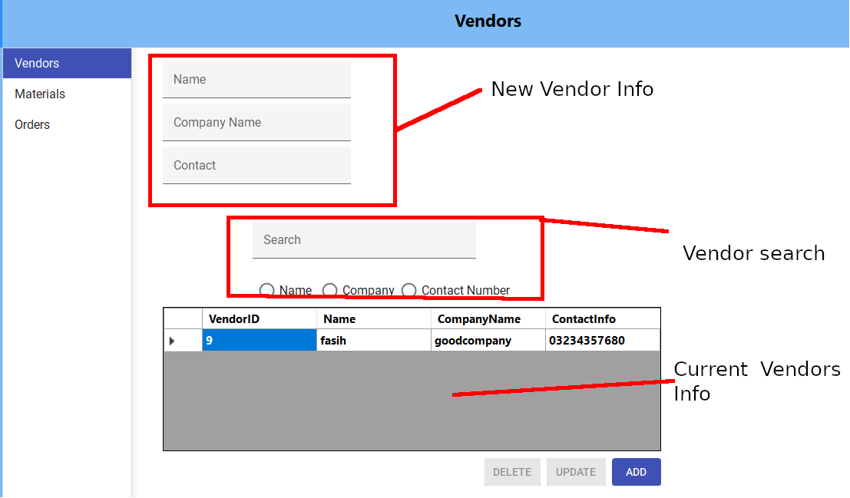

## Orders

Orders tab is for the adding, cancellation, removal of orders

You

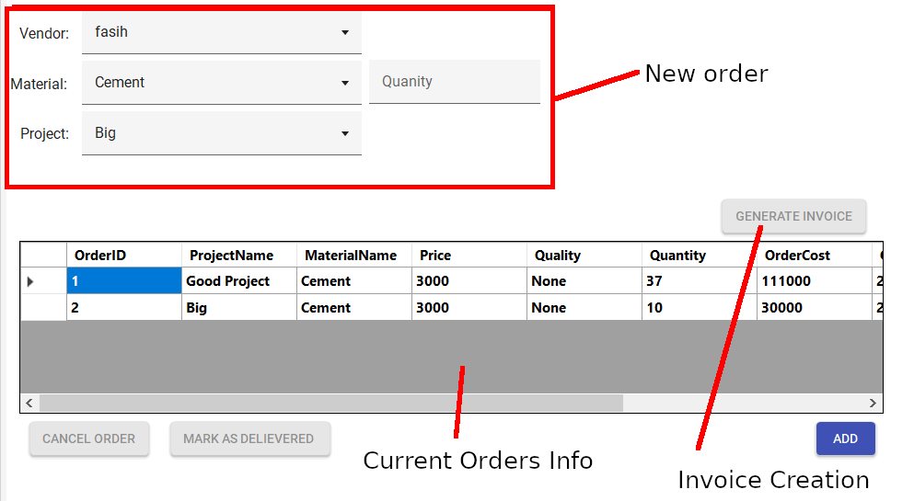

## Materials

For the addition, updating and deletion of materials

## Sign Up

For adding and removing users

## Assign Work

This is used to assign employees to projects

First Click on the desired employee, Select the desired project and dismiss or assign the employee.

